**Comparison of Region Based on Sales**

1. Primary Measures:

1. Secondary Measures

1. Primary Map

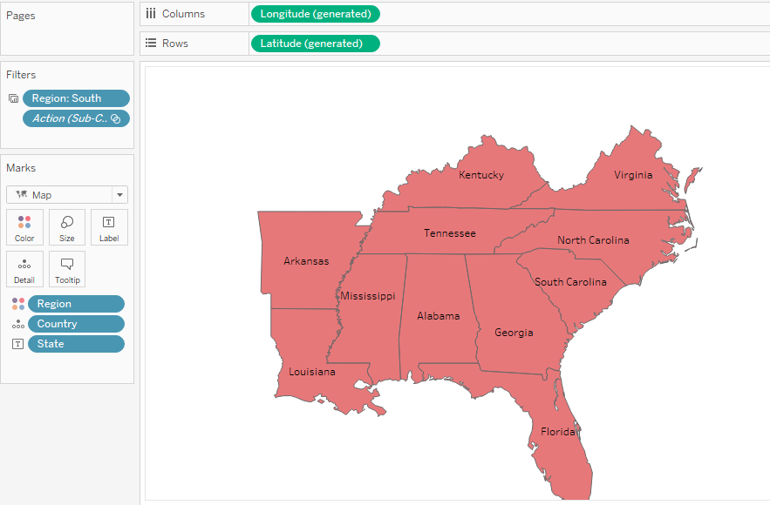

1. Secondary Map

1. Primary Sub-Category

1. Secondary Sub-Category

1. Primary Sparklines

1. Secondary Sparklines

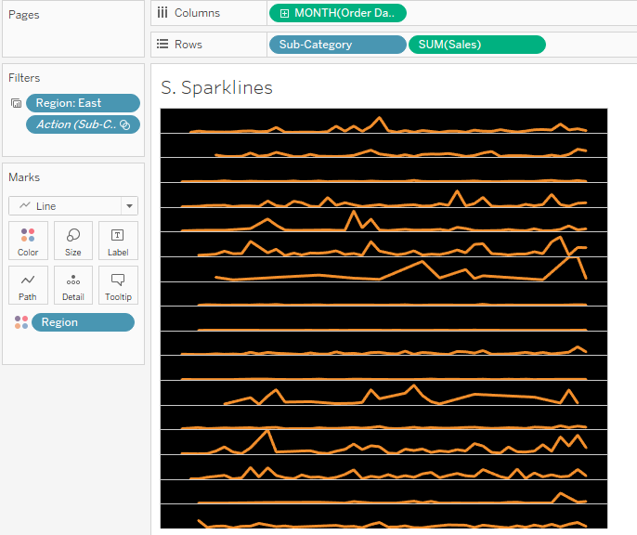

1. Primary Bar Graph

1. Secondary Bar Graph

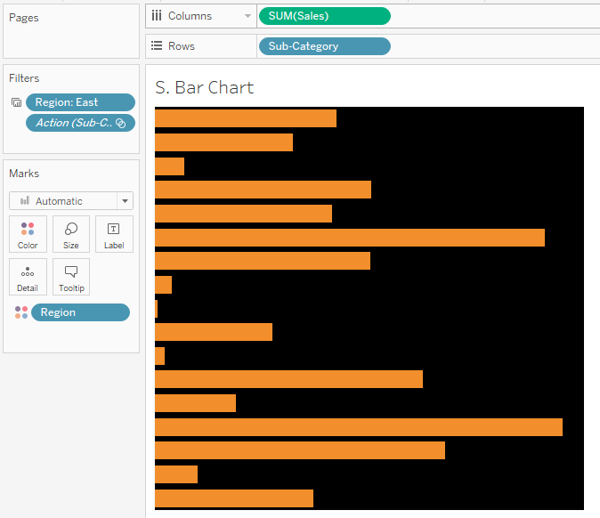

1. Final Dashboard

